**Extending Shabda Pariksha using Machine learning.**

**Mentor Code : BJS1_M120, Mentor : Dr. Nataraj K S, Intern : Harshita.N.G.**

**Background:** Traditional Ayurveda employs eight different clinical examination techniques (referred to as Ashtavidha Pariksha) for two purposes: diagnosing diseases and comprehending the condition of any person. Shabda Pariksha, which is one of the eight parikshas, is voice-based. According to Ayurveda, the three doshas (Vata, Pitta, and Kapha) can be predicted based on voice quality. Aside from disease diagnosis and prognosis, Nadi Pariksha (another one of the eight types, which is based on the pulse) is used to predict various psychological tendencies (likings and dislikes), passions, soft skills, and other personal attributes of any person. In the case of Shabda Pariksha, such predictions, however, are not found in the literature. The current effort seeks to further Shabda Pariksha's understanding of the relationship between voice and many human characteristics, including preferences for and aversions to certain hues, topics, musical genres, climatic situations, and food preferences. This project is thus necessary to be undertaken since it is beneficial in helping to understand the relation between voice and personality traits.

**Objectives:**

* Collecting a good data set of audio recordings and personal traits from people belonging to different backgrounds of the society.
* To build ML / DL based predictors to find correlations amongst the personality traits, the three doshas and the voice, based on the data set as outlined above with good accuracy.

**Description:** We will be collecting a good dataset of audio recordings and personal traits of people from different backgrounds of society. We will make sure to make the data collection process to be as natural as possible so that the natural expressions and habits can be captured. The dataset will include features such as favorite color, genres of music and films, dislikes, and so on. We will also ensure that devices with comparable sound and video quality are used for more accurate results. We will then utilize this data to build a machine learning / deep learning model to determine the relationship between voice and the other qualitie with good accuracy and performance. The next step will be applying the model to testing data and getting good accuracy and performance by checking true data and predicted data using appropriate metrics measures, consolidating it, and validating it.

**Timelines**

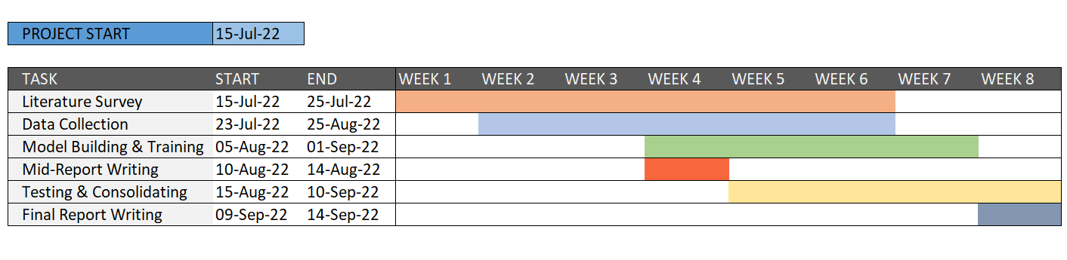

**Output:**

i) A database consisting of audio data and personal traits, without disclosing personal details.

ii) Good ML / DL based automatic predictors of the three doshas and analysis of personality traits with good prediction accuracies.

iii) A research paper to be published in a journal after the internship, based on the obtained results.